TRAVEL EXPENSE SPLITTER
@CREATIVITY THINK (9483175986/7019689991)

ABSTRACT:
The Travel Expense Splitter is a web application designed to help groups manage shared travel expenses efficiently. Users can create or join trips, log group expenses, calculate fair splits, settle balances, and access detailed dashboards. Administrators can add or edit trip templates, moderate groups and expenses, and analyze spending patterns through analytics dashboards. The backend uses Django and Django Rest Framework for secure data handling, authentication, and business logic, while the frontend leverages React, Redux, and Recharts for interactive dashboards and visualization. The system ensures transparency, accountability, and easy expense management for group travels..

INTRODUCTION OF THE PROJECT:
Managing group travel expenses can be complex and prone to errors without proper tracking. The Travel Expense Splitter addresses this by offering a centralized web application that allows group members to log expenses, calculate splits automatically, and settle payments. Administrators can oversee trips, moderate group expenses, and generate analytics to ensure fairness and transparency. Using Django and Django Rest Framework for the backend and React, Redux, and Recharts for the frontend, the platform provides secure, real-time expense tracking with intuitive dashboards for users and administrators..

PROJECT OBJECTIVES:

• Enable users to create and join group trips
• Log expenses and automatically calculate fair splits
• Allow users to settle balances and track payments
• Provide dashboards for expense tracking and reporting
• Allow administrators to add/edit trip templates
• Moderate groups, expenses, and user activity
• Generate analytics and insights for trip spending patterns

PROBLEM OF THE STATEMENT:
Group travel often involves shared expenses which are difficult to track and split fairly among participants. Manual calculations may lead to confusion, disputes, or missed payments. Administrators require tools to moderate trips, monitor expenses, and maintain transparency. The Travel Expense Splitter solves these problems by providing a web-based platform for logging expenses, calculating splits, settling balances, and viewing analytics dashboards, ensuring smooth and fair financial management for group travel..

MOTIVATION OF THE PROJECT:
• Facilitate fair and transparent expense sharing among travelers
• Simplify expense logging and tracking during trips
• Provide interactive dashboards for easy monitoring
• Allow administrators to moderate and manage trips efficiently
• Reduce disputes and improve financial clarity for group travel

BLOCK DAIGRAM OF PROJECT:

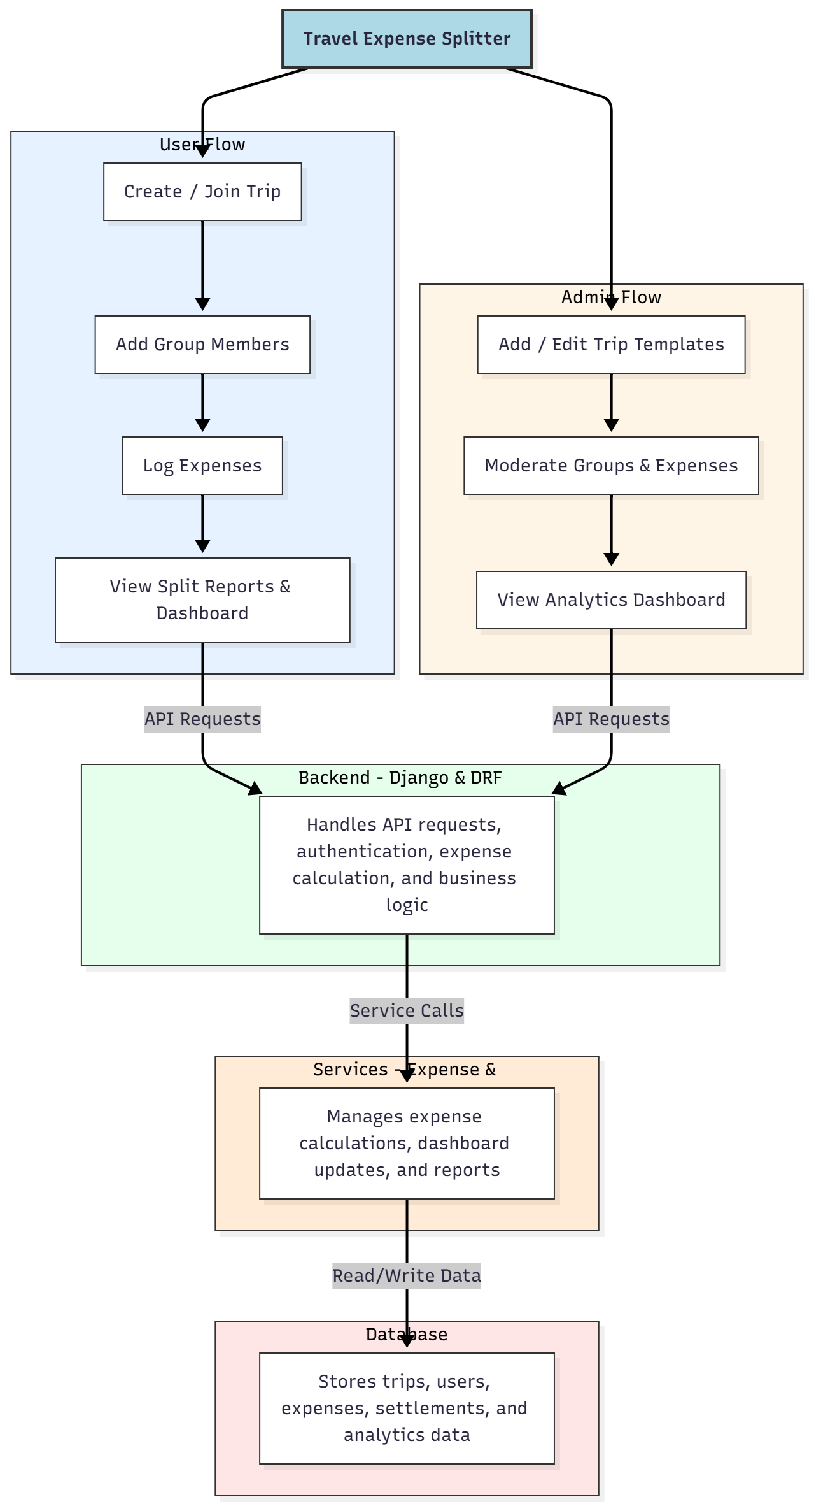

WORKING OF THE PROJECT:
Users create or join a trip, add members, and log shared expenses. The backend calculates fair splits automatically and updates dashboards. Users can view expense summaries and settle payments. Administrators can add or edit trip templates, moderate groups and expenses, and analyze spending patterns through analytics dashboards. The system ensures accurate expense tracking, transparency, and efficient group financial management throughout the travel period..

SOFTWARE REQUIREMENT:
- Backend:
  - Python 3.x
  - Django
  - Django REST Framework
  - SQLite/PostgreSQL
- Frontend:
  - Node.js and npm
  - React.js
  - Axios
- Development Tools:
  - Visual Studio Code
  - Postman (for testing APIs)
  - Git/GitHub (for version control)
- Server/Deployment (Optional):
  - Gunicorn, Nginx, or Heroku/AWS for hosting

ADVANTAGES OF THE PROJECT:

• Simplifies group expense management
• Automatic fair split calculations
• Secure and real-time transaction tracking
• Administrators can moderate trips and expenses
• Interactive dashboards for analytics
• Reduces disputes and confusion in shared finances
• Accessible via web browsers on multiple devices
• Efficient record-keeping for all trip-related expenses

APPLICATIONS OF THE PROJECT:
• Friends and family group trips
• Travel clubs and group tours
• Corporate team outings
• College and student travel events
• Club or organization travel expense management
• Dashboard-based expense analytics
• Mobile-friendly web interface for remote access
• Integration with financial reporting tools

REFERENCES:

- Django REST Framework Documentation — Django Software Foundation. Django Documentation. Available: https://docs.djangoproject.com/
- Django REST Framework. DRF Documentation. Available: https://www.django-rest-framework.org/
- React. React Official Documentation. Available: https://reactjs.org/docs/getting-started.html
- Redux. Redux Documentation. Available: https://redux.js.org/introduction/getting-started
- PostgreSQL Global Development Group. PostgreSQL Documentation. Available: https://www.postgresql.org/docs/
- MySQL. MySQL Reference Manual. Available: https://dev.mysql.com/doc/
- Git. Git Documentation. Available: https://git-scm.com/doc
- Node.js. Node.js Documentation. Available: https://nodejs.org/en/docs/
- Axios. Axios Documentation. Available: https://axios-http.com/docs/intro
- Socket.io Documentation – https://socket.io/docs/

